AFFINEUR OF THE YEAR 2024 | CH09
Cheese Name | Pwll Du
Cheesemaker | Quicke’s
Date cheese received | 19th July
Statement of Intent / Objective
Describe your organoleptic objectives through affinage of this cheese: style, texture, colour, rind and flavour profile,  Why did you choose this route for the cheese? - the story | Our intent is to re-create a coal mine environment, encasing the cheese in a wall of coal.  Coal mining has a rich history within Wales especially in the areas of South Wales where I grew up.  The coal walls are designed to keep a constant temperature ensuring the harsh air flow from the fridge unit does not affect the maturation.  To ensure levels of humidity are maintained the coal walls will also feature a constant flow of running water; this will be pumped back over the coals.  These conditions will hopefully allow the cheese to retain the creaminess of a much younger cheese whilst allowing the natural microflora to thrive creating a unique flavour profile.
Method
Describe your plan for the affinage parameters, including temperature, humidity and airflow.  Compare target and actual, and provide reasoning for any corrective actions. A summary of your daily/weekly/monthly records. | We intend keeping the temperature between 10-12°C at 90% humidity for the first 9 months of maturation.  We’ll use water to create the humidity by gently allowing water to flow down along the coal walls that encase the cheese.  For the final 4 months of maturation, we intend to remove the cloth rind to form a hard natural rind by washing it with Welsh Sea Salt.
End Result / Conclusion: what have you learned during this process?

Our coal chamber kept the cheese at a constant temperature of between 10-12°C; preventing any harsh air flow from the refrigerator.
Initially we turned the cheese every 2 weeks and then for the last 6 months every month.
Due to issues in keeping the humidity at a constant 90% we kept the cloth intact to help prevent the cheese from drying out.
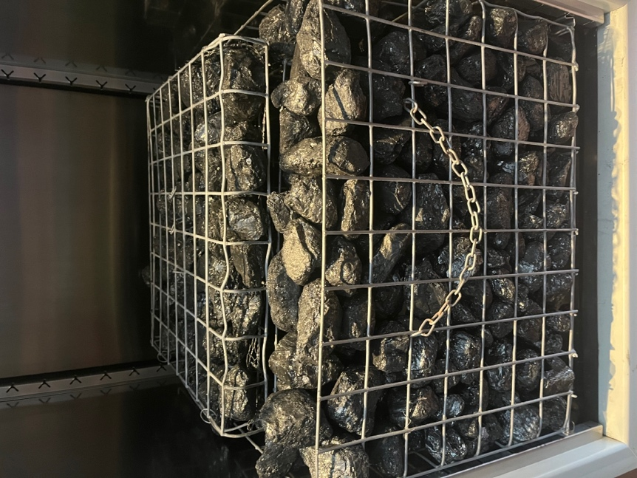

COAL CHAMBER

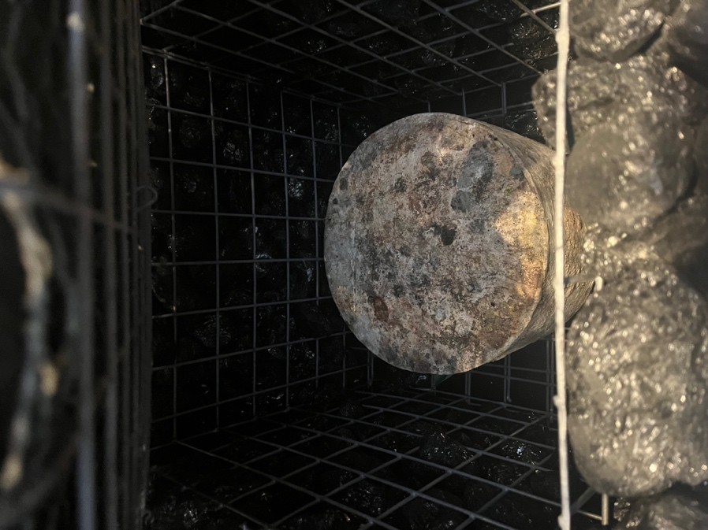

CHEESE MATURING

